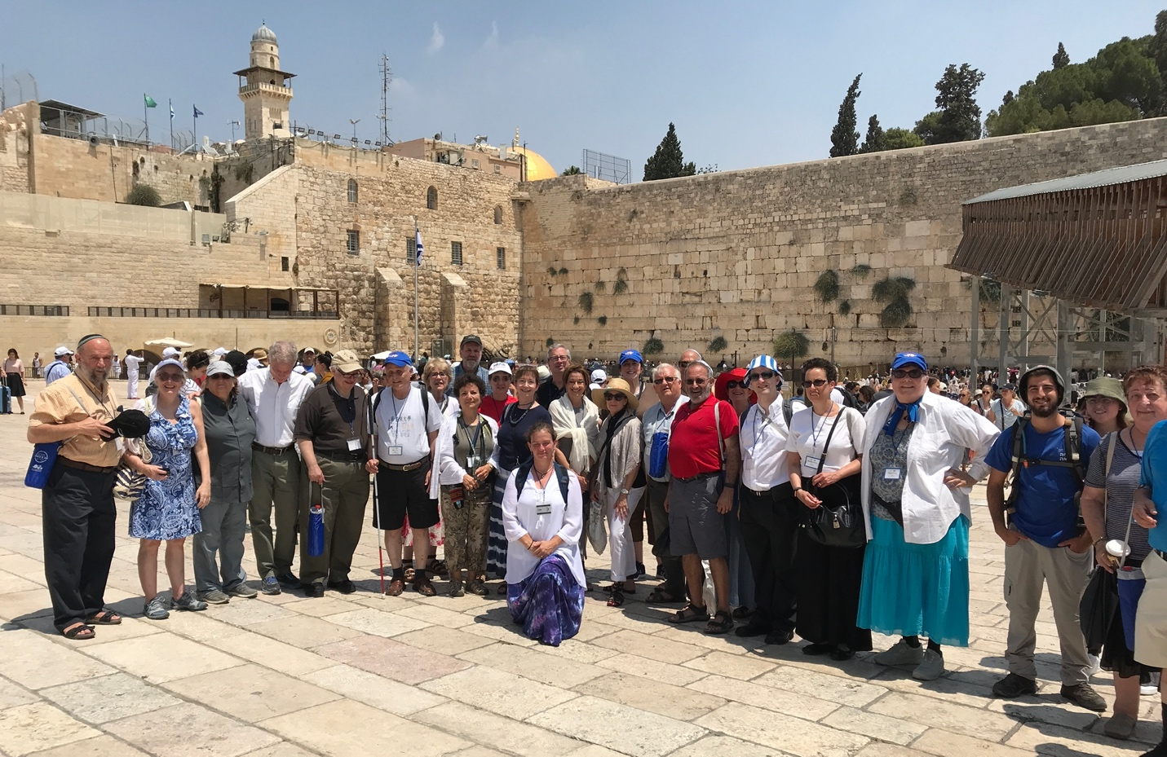

ISRAEL @ 75 Mission Fact Sheet

Thank you for your interest in our Zamir Choral Foundation Israel @ 75 Mission to Celebrate 75 years of Israel and our shared history and future.

Below you will find answers to many of your questions. If you have additional questions or need clarification, please reach out to Bobbie Sue at Israel75@ZamirChoralFoundation.org.

- What are the dates of the Mission?

Our Mission in Israel starts on Sunday morning, July 30th and ends on Sunday, August 6th, 2023. There is a Pre-Mission as well from Wednesday July 26th- July 30th.

- Who is the Mission for?

This Mission is for anyone who loves to sing and as well as for lovers of music who might not sing and who want to Celebrate Israel @ 75 by touring Israel through song with a terrific group of participants! This trip is for those who are visiting Israel for the first time, as well as those who have traveled to Israel many times.

2. Where are we staying and what’s the price?

We will be staying at Dan Panorama Hotels. Our current plan is to start at the Dan Panorama Jerusalem, travel North with an overnight at the Dan Panorama Haifa and then end at Dan Panorama Tel Aviv. Pricing is found on the Pricing for Participants page.

The maximum land price is $4300 with a minimum of 30 people to run the trip; prices will go down with greater numbers of participants. Single supplements are available if you prefer your own room. If you need a roommate, please let me know as soon as possible so I can start making those shidduchs as available. The more people who join us, the lower the price, so encourage your friends, family and neighbors to come! Everything is based on availability and Israel is very popular right now, so get your registration in to secure your space and room at the hotels! See our pricing page.

3. What music will we sing and where are the concerts?

We won’t be able to select music until we know who has committed to come on the mission. The level of our singers and balance of parts will determine the repertoire. That will also determine our performance venues (nursing homes/hospitals and/or a concert in a more formal hall). We will tailor our exact itinerary to create the best possible travel and performance opportunities.

4. And rehearsals?

We do hope to hold rehearsals in June or early July in the New York area, as well as one or two at the North American Jewish Choral Festival, July 9 – 13. We’ll announce those rehearsal dates as soon as possible. Participants outside the New York area will be able to participate in rehearsals prior to the mission through FB live, WhatsApp or Zoom (TBD). Additionally, we will send out part tapes to everyone as music is chosen.

During the mission we’ll start each morning with a rehearsal after breakfast (and allowing free time or late breakfast for those not singing).

5. Where are we going in Israel on the Mission?

We’re planning to start our trip in in Jerusalem, travel to the North, and then, make our way to Tel Aviv for Shabbat. Those wanting a more relaxed Shabbat at the beach or time at the Port, can enjoy that in TA. Those wanting to attend Shabbat services will receive information about options in Tel Aviv. Additionally, there are many museums open on Shabbat in TA.

6. And the Pre-Mission?

We foresee the Pre-Mission as a way for anyone to get to Israel a bit early and relax. Wednesday night/ Thursday is Tisha B’Av and we look forward to hearing Eichah/Lamentations together (or people can choose to visit the Kotel.) We’re planning to have a program at Yad Vashem on Thursday morning, then the rest of Thursday will be free time for all. I see Friday as free, but I’m sure I will be going to the shuk and/or Ben Yehuda Street and I am happy to take anyone with me, and there will likely be other options to suggest. (There are a number of new things to see in Jerusalem and what cannot be included in the Mission will be suggested as options here.) Shabbat will be a free day to relax with the exception of Friday night, when we will all have dinner together at the hotel. Saturday is open and of course, I’ll be giving everyone listing of synagogues in advance. This will be Shabbat Nachamu, (the Shabbat after Tisha B’Av which is traditionally a Shabbat of great celebration) so there will likely be special events going on in Jerusalem on Saturday night. We’ll let attendees know about some activity options and whether or not tickets are needed for any of them. The only transportation provided during this pre-Mission will be on Wednesday night and Thursday morning. In general, the Pre-Mission is intended for us to spend Tisha B’Av together and make it a meaningful start to our Mission, along with plenty of free time.

7. Covid

We realize many have concerns about traveling during days of Covid. While none of us can be sure of what will be, we know that the world has opened to travel.

At the present time, Israel is not requiring proof of vaccinations or negative Covid testing, but those requirements could change. We’ll convey any updates as they are announced.

We expect to follow CDC suggestions regarding Covid. At this time, one must isolate for 5 days upon being diagnosed. If the same applies at the time of the Mission, the following would apply:

- We suggest that everyone bring along several rapid tests and self-test every 3-4 days.
- If you have symptoms of Covid, test immediately and wear a mask.
- If you test positive for Covid, you will not be allowed to be on the bus with us or join us for programming for 5 days (current number). You will self-quarantine in the hotel. After 5 days and end of symptoms, one may rejoin the Mission wearing a mask. Additionally, here is the Israeli government Covid site: https://corona.health.gov.il/en/. Any updated rules will need to be followed.
- All participants are encouraged to wear a mask at all times on the bus and inside rooms but are not required to do so.
- The Zamir Choral Foundation and Mission cannot accept responsibility for your care if you test positive for Covid (or any other illness/sickness or injury).

8. Travel Insurance

Travel insurance which has Covid and cancellation coverage is strongly encouraged. Make certain that your insurance covers extra nights in hotels, if necessary for health reasons, catching up to your tour, and/or new flights home, and that you understand fully what the insurance covers.

We’ve been asked about Travel Insurance companies. To inquire about insurance coverage, consider contacting:

- Bill Gross at 212-630-4040 x17 and/or
- AJ Steele at Faye at 402-517-5087 or aj.steele@withfaye.com

9. On another note

All US passport holders must have valid passports for 6 months or more upon return from the trip. That means they must not expire prior to February 2024. Check to make sure that your passports have time or renew your passport asap.

Hope all of this is helpful. Please reach out to me if you have additional questions and to register!

Bobbie Sue Daitch
Mission Chair
Israel75@zamirchoralfoundation.org

